Day 3 Assignment:
1)For the given JSON iterate over all for loops (for, for in, for of, forEach) ?
for Loop:

- var info = [
- { person: "Savitha", age: "21", company: "Dell" },
- { person: "Sanjay", age: "18", company: "IBM" },
- { person: "Pooja", age: "17", company: "Accenture" },
- ];
- //normal for loop
- let result = " ";
- for (let i = 0; i < info.length; i++) {
- result += `
- person:${info[i].person}
- age:${info[i].age}
- company:${info[i].company}
- `;
- }

- console.log(result);

Output:
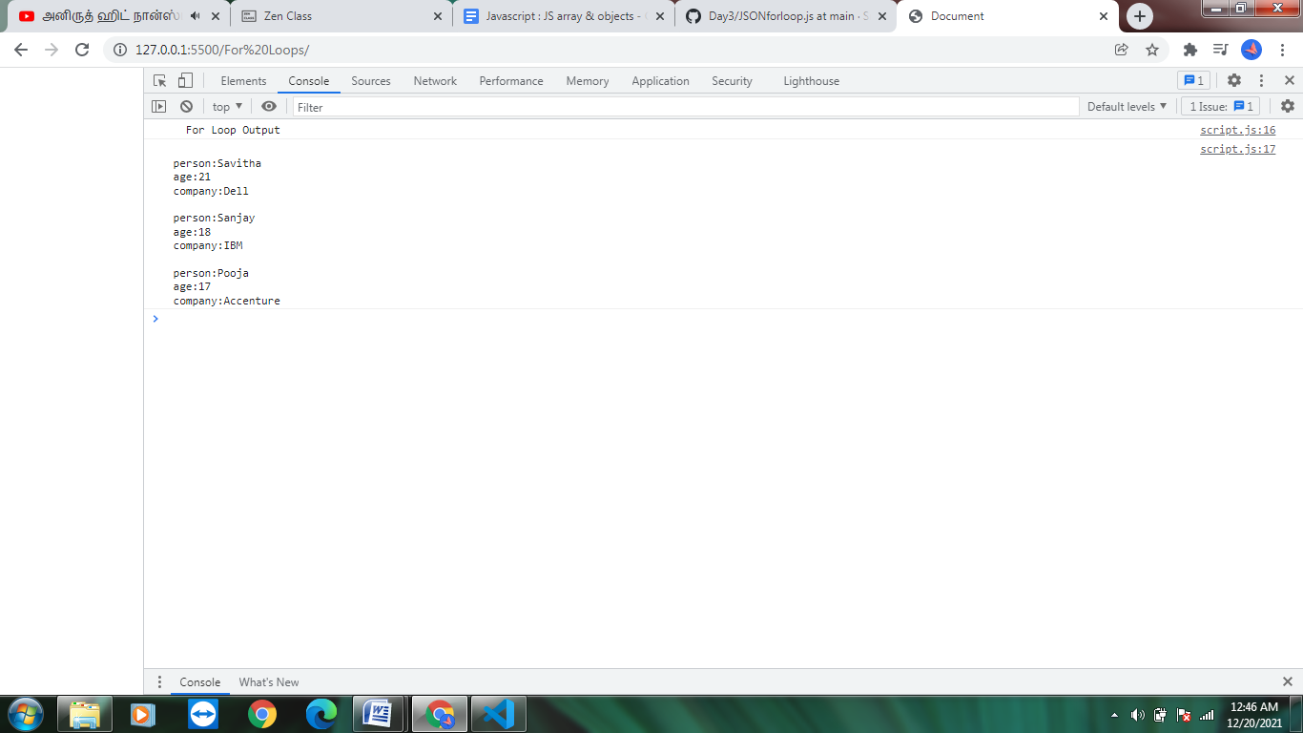

for in Loop:
var info = [
{ person: "Savitha", age: "21", company: "Dell" },
{ person: "Sanjay", age: "18", company: "IBM" },
{ person: "Pooja", age: "17", company: "Accenture" },
];

//for in loop

let final = " ";
for (let index in info) {
final += `
person:${info[index].person}
age:${info[index].age}
company:${info[index].company}
`;
}
console.log(final);

Output:
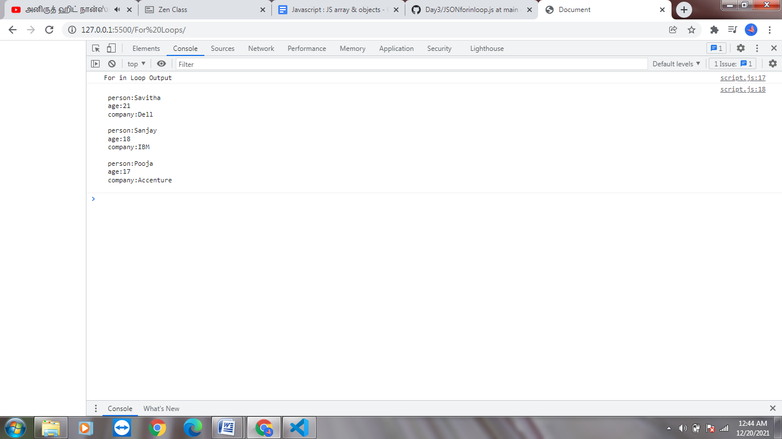

for of Loop:
var info = [
{ person: "Savitha", age: "21", company: "Dell" },
{ person: "Sanjay", age: "18", company: "IBM" },
{ person: "Pooja", age: "17", company: "Accenture" },
];

//for of loop

result = " ";
for (let informations of info) {
result += `
person:${informations.person}
age:${informations.age}
company:${informations.company}

`;
}
console.log(result);

Output:
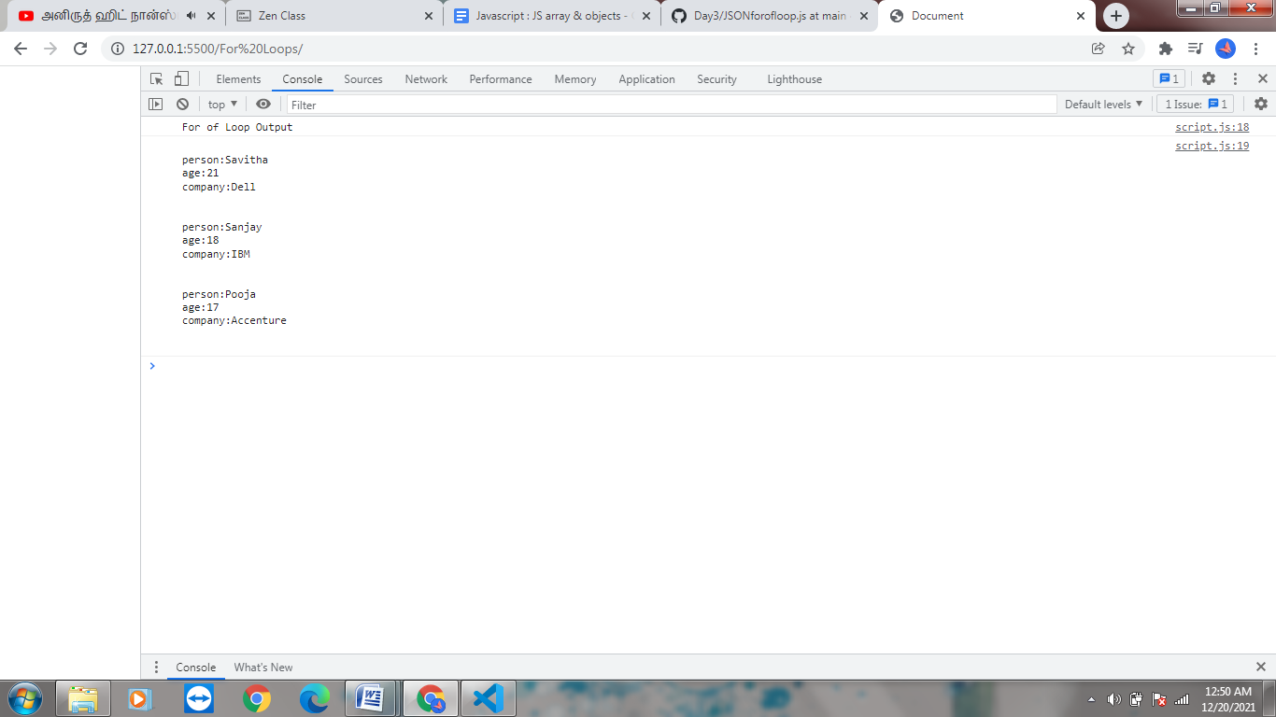

forEach Loop:
var info = [
{ person: "Savitha", age: "21", company: "Dell" },
{ person: "Sanjay", age: "18", company: "IBM" },
{ person: "Pooja", age: "17", company: "Accenture" },
];

//for each loop

result = " ";

info.forEach(function (information) {
result += `
person:${information.person}
age:${information.age}
company:${information.company}
`;
});
console.log(result);

Output:
